Feast of Mary, Mother of God
1st January 2024

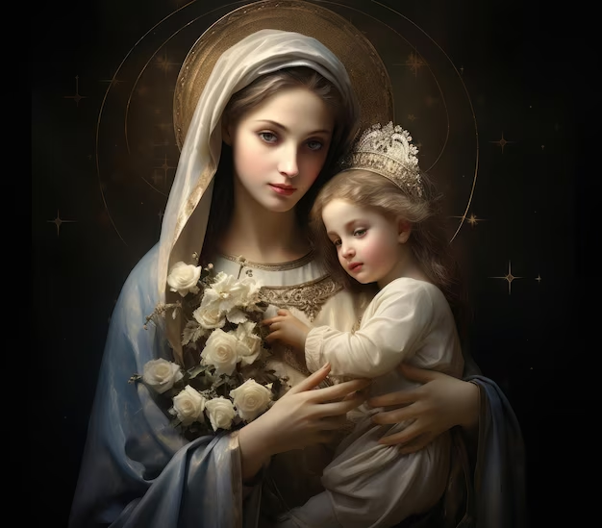

Entrance Antiphon
Hail, Holy Mother, who gave birth to the King,
who rules heaven and earth for ever.

Or:

Today a light will shine upon us, for the Lord is born for us;
and he will be called Wondrous God,
Prince of peace, Father of future ages:
and his reign will be without end.

Collect
O God, who through the fruitful virginity of Blessed Mary
bestowed on the human race
the grace of eternal salvation,
grant, we pray,
that we may experience the intercession of her,
through whom we were found worthy
to receive the author of life,
our Lord Jesus Christ, your Son.
Who lives and reigns with you in the unity of the Holy Spirit,
God, for ever and ever.
Liturgy of the Word

First Reading Numbers 6:22-27
They are to call down my name on the sons of Israel, and I will bless them.

The Lord spoke to Moses and said, ‘Say this to Aaron and his sons: “This is how you are to bless the sons of Israel. You shall say to them:

May the Lord bless you and keep you.
May the Lord let his face shine on you and be gracious to you.
May the Lord uncover his face to you and bring you peace.”

This is how they are to call down my name on the sons of Israel, and I will bless them.’

The word of the Lord.
Thanks be to God.

Responsorial Psalm 66: 2-3, 5, 6, 8
R./: May God bless us in his mercy.
O God, be gracious and bless us
and let your face shed its light upon us.
So will your ways be known upon earth
and all nations learn your saving help. (R./)

Let the nations be glad
and exult for you rule the world with justice.
With fairness you rule the peoples.
you guide the nations on earth. (R./)

Let the peoples praise you, O God;
let all the peoples praise you.
May God still give us his blessing
till the ends of the earth revere him. (R./)
Second Reading Galatians (4:4-7)
God sent his Son, born of a woman.

When the appointed time came, God sent his Son, born of a woman, born a subject of the Law, to redeem the subjects of the Law and to enable us to be adopted as sons. The proof that you are sons is that God has sent the Spirit of his Son into our hearts: the Spirit that cries, ‘Abba, Father’, and it is this that makes you a son, you are not a slave any more; and if God has made you son, then he has made you heir.

The word of the Lord.
Thanks be to God.

Gospel Acclamation Heb1:1-2

Alleluia, alleluia!
At various times in the past
and in various different ways,
God spoke to our ancestors through the prophets;
but in our own time, the last days,
he has spoken to us through his Son.
Alleluia!

Gospel (Luke 2:16-21)
The shepherds hurried to Bethlehem and found the baby lying in the manger.

The shepherds hurried away to Bethlehem and found Mary and Joseph, and the baby lying in the manger. When they saw the child they repeated what they had been told about him, and everyone who heard it was astonished at what the shepherds had to say. As for Mary, she treasured all these things and pondered them in her heart. And the shepherds went back glorifying and praising God for all they had heard and seen; it was exactly as they had been told.
When the eighth day came and the child was to be circumcised, they gave him the name Jesus, the name the angel had given him before his conception.

The Gospel of the Lord.
Praise to you, Lord Jesus Christ.

Prayers of the Faithful

Celebrant: At the beginning of the New Year, we turn to God our Father, through the intercession of Mary humbly asking for our needs and the needs of the world.

For the Church: that in this coming year all who follow Christ will be more courageous in their witness to the faith and united in their discipleship of the Lord. Lord, hear us.

For all in our community who will receive the sacraments this coming year; may the grace of the sacraments and the power of the Holy Spirit transform them into the image of Christ. Lord, hear us.

On this World Day of Prayer for Peace, we pray for peace in our world. May the light of Christ’s love transform the minds and hearts of those consumed by their quest for power, conflict, and destruction. Lord, hear us.

For an end to hatred in our world. May the darkness of racism, homophobia, religious divisions, wars, and every violence be brought into the light of faith, trust, and peace. Lord, hear us.

For couples trying to conceive; may God who brought life into the world bless them with the gift of life to love and cherish. Lord, hear us.

For all mothers, that they may find in Mary, the mother of God a model of profound humility, lively faith, patience, wisdom, trust, and joy. Lord, hear us.

For all who are sick: those in hospital, those undergoing treatment for cancer, those living with life-limiting illnesses or conditions, and those sick at home. Accompany them in times of trial and bless them with the gift of wholeness and healing. Lord, hear us.

For all who have died; grant them eternal rest. Lord, hear us.

Celebrant: Lord our God, you draw near to us in the Christ-child born of the Virgin Mary. Open our hearts and minds to the many blessings you offer in this New Year. We ask this through Christ, our Lord. Amen.

Prayer over the Offerings
O God, who in your kindness begin all good things
and bring them to fulfilment,
grant to us, who find joy in the Solemnity of the holy Mother of God,
that, just as we glory in the beginnings of your grace,
so one day we may rejoice in its completion.
Through Christ our Lord.

Preface: The Motherhood of the Blessed Virgin Mary

The Lord be with you.
And with your spirit.

Lift up your hearts.
We lift them up to the Lord.

Let us give thanks to the Lord our God.
It is right and just.

It is truly right and just,
our duty and our salvation,
always and everywhere to give you thanks,
Lord, holy Father,
almighty and external God,
and to praise, bless
and glorify your name
on the Solemnity of the Motherhood
of the Blessed ever-Virgin Mary.

For by the overshadowing
of the Holy Spirit
she conceived your
Only Begotten Son,
and without losing the glory of virginity,
brought forth into the world
the eternal Light,
Jesus Christ our Lord.

Through him the Angels praise your majesty,
Dominions adore and Powers tremble before you.
Heaven and the Virtues of heaven
and the blessed Seraphim
worship together with exultation.
May our voices, we pray,
join with theirs
in humble praise, as we acclaim:

Holy, Holy, Holy Lord God of hosts.
Heaven and earth are full of your glory.
Hosanna in the highest.
Blessed is he who comes in the name of the Lord.
Hosanna in the highest.

Communion Antiphon Heb 13: 8
Jesus Christ is the same yesterday, today, and for ever.

Post Communion Reflection

“May the Virgin Mary, who gave birth to the “Prince of Peace” (Is 9:6), and who cuddles him this way, with such tenderness in her arms, obtain for us from heaven the precious gift of peace, which cannot be fully pursued by human strength alone. Human strength alone is not enough because peace is above all a gift, a gift of God; it should be implored with unceasing prayer, sustained with patient and respectful dialogue, constructed with an open cooperation with truth and justice and always attentive to the legitimate aspirations of individuals and peoples. My hope is that peace may reign in the hearts of men and women and in families, in places of work and of recreation, in communities and in nations. In families, at work, in nations: peace, peace. Now is the time to think that life today is organized around war, and enmities, by many things that destroy. We want peace. And this is a gift.”

Pope Francis, Jan. 1, 2021

Prayer after Communion
We have received this heavenly Sacrament with joy, O Lord:
grant, we pray,
that it may lead us to eternal life,
for we rejoice to proclaim the blessed ever-Virgin Mary
Mother of your Son and Mother of the Church.
Through Christ our Lord.

Solemn Blessing for the New Year
May God, the source and origin of all blessing,
grant you grace,
pour out his blessing in abundance,
and keep you safe from harm throughout the year.
Amen.

May he give you integrity in the faith,
endurance in hope,
and perseverance in charity
with holy patience to the end.
Amen.

May he order your days and your deeds in his peace,
grant your prayers in this and in every place,
and lead you happily to eternal life.
Amen.

And may the blessing of almighty God,
the Father, and the Son, and the Holy Spirit,
come down on you and remain with you forever.
Amen.

